JavaScript Programming class – Installation guide
Notes: All the software is free, but first you must disable Windows S if you haven’t already

Install VSC (Visual Studio Code)

https://code.visualstudio.com/docs/?dv=win64user
warning: this will automatically download the install file, if it doesn't, click on 'direct download link'

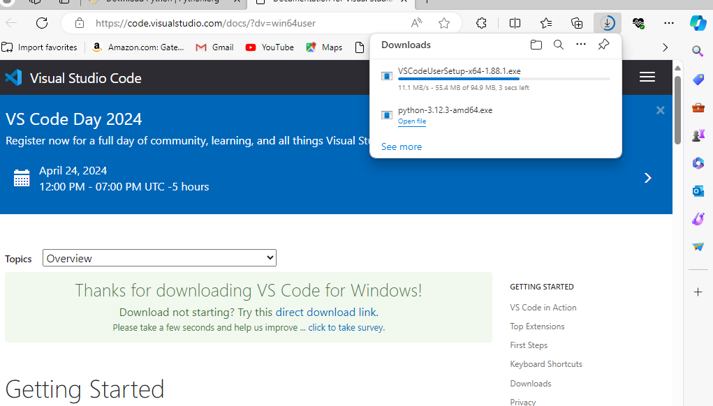

Go to your downloads folder and double click on the file just downloaded

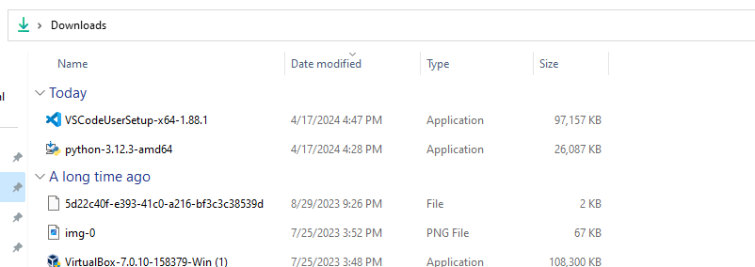

click to Accept then next

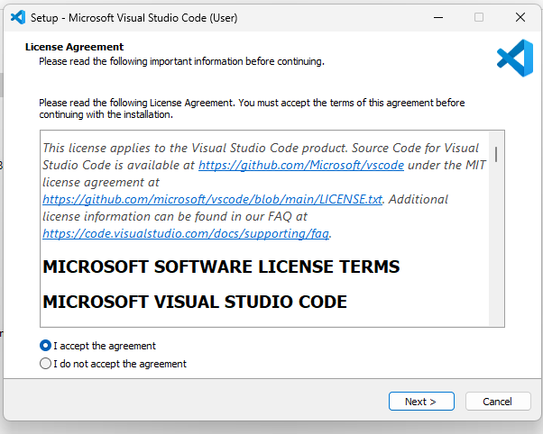

click next

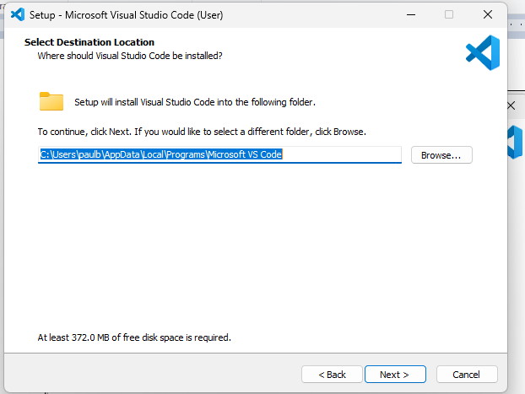

click next

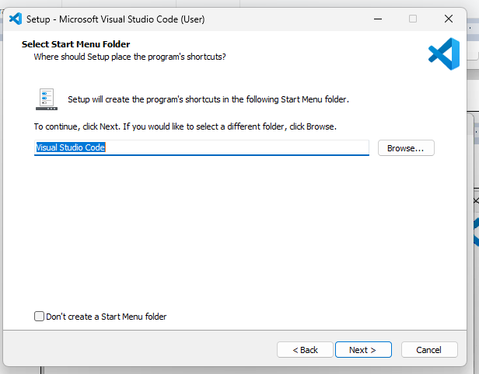

keep the 2 defaults checked, click next again

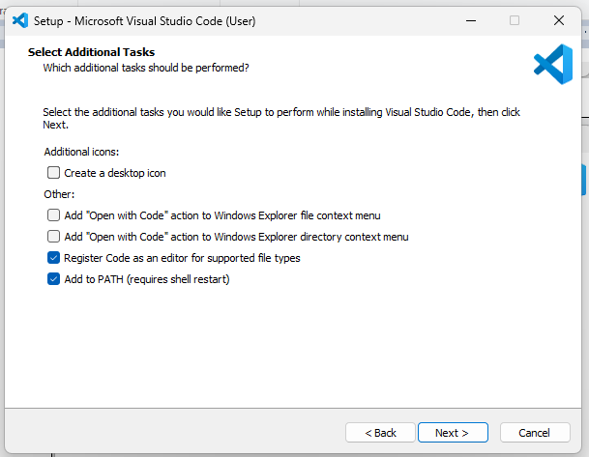
click Install

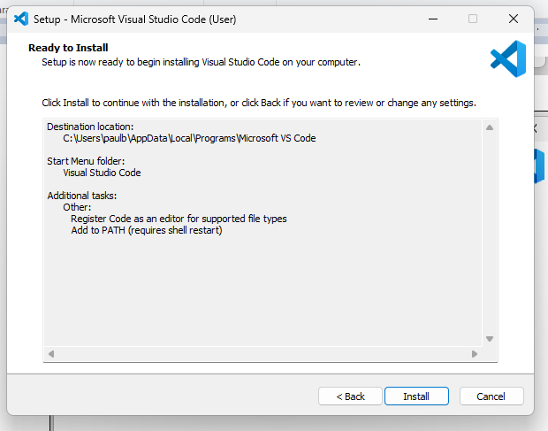

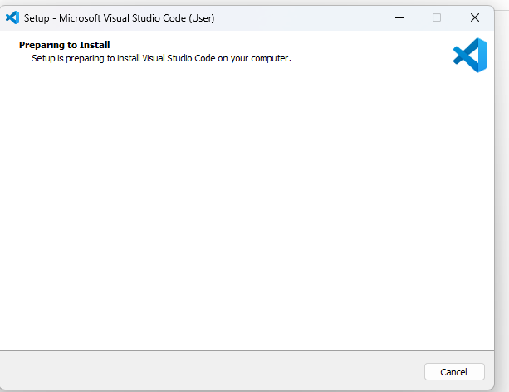

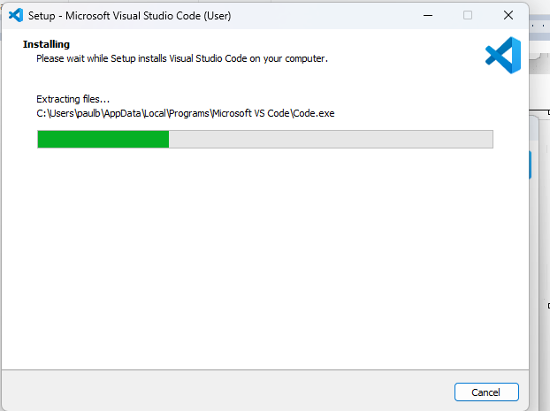

click Finish and launch into VSC
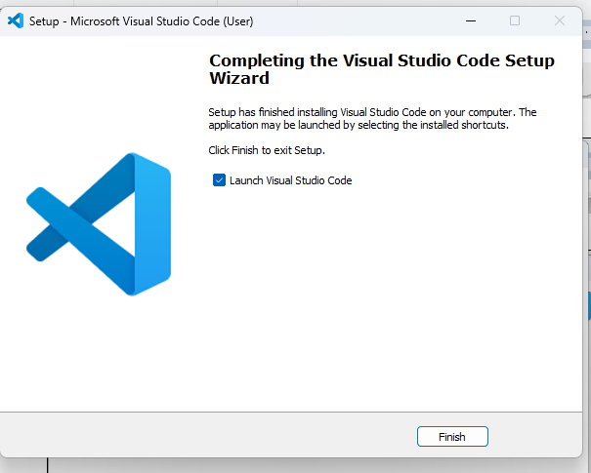

VSC pulls up
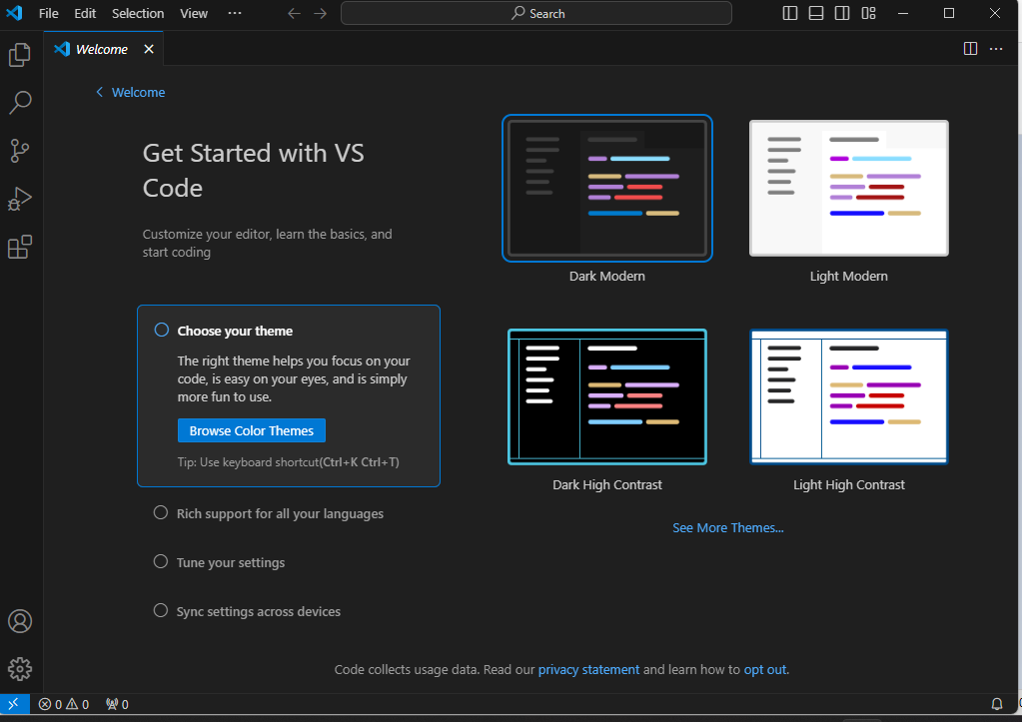

Install the Live Server inside VSC then try some JavaScript coding!

Create the JavaScriptVSC folder in your documents folder e.g. C:\Users\paulw\Documents\JavaScriptVSC
Then go back to VSC

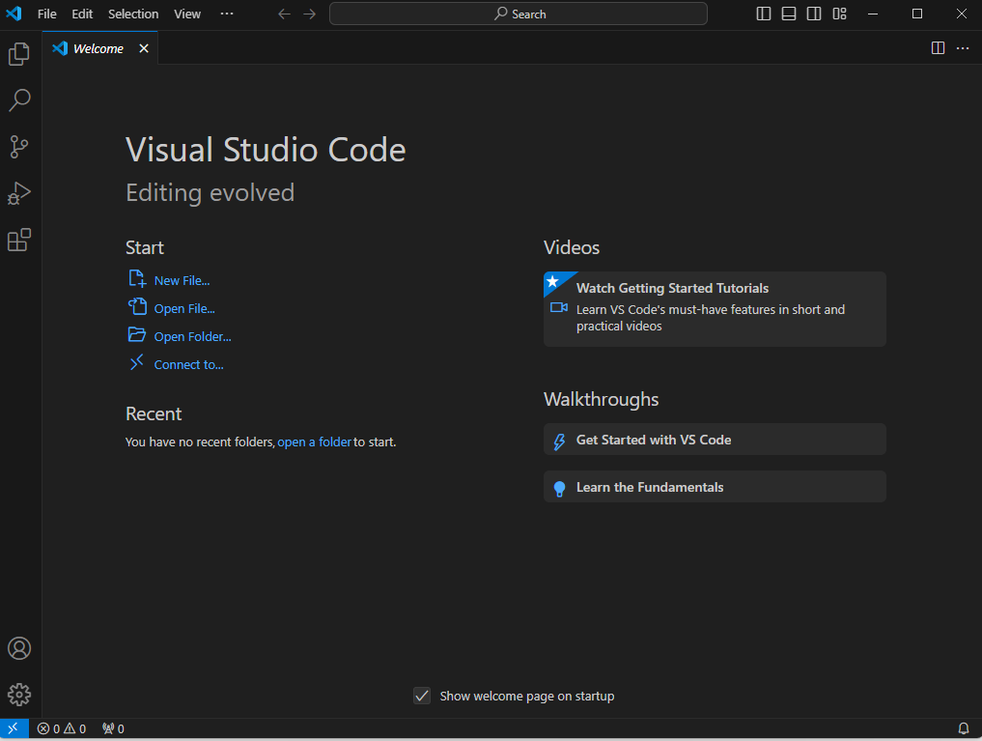

Click on file -> open folder, drill to folder you created, click Select Folder
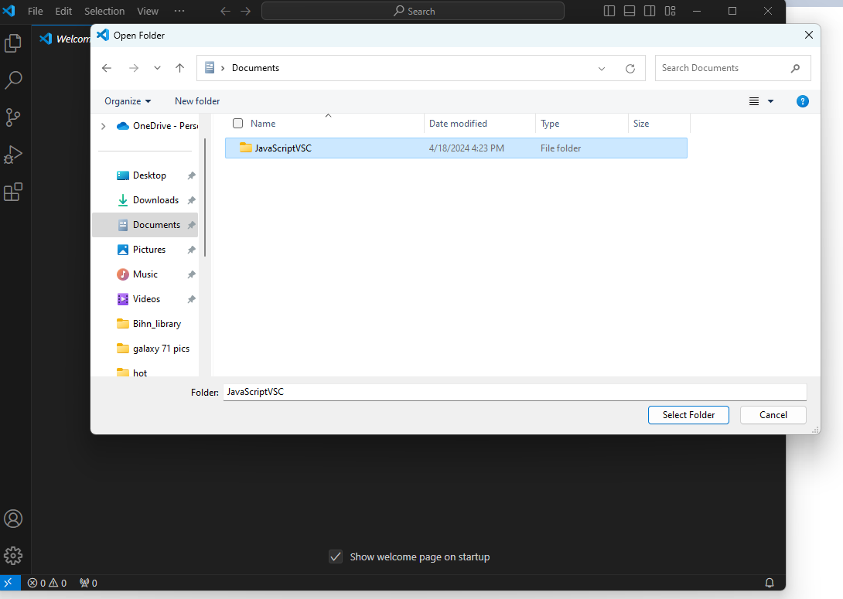
click Yes I trust the authors
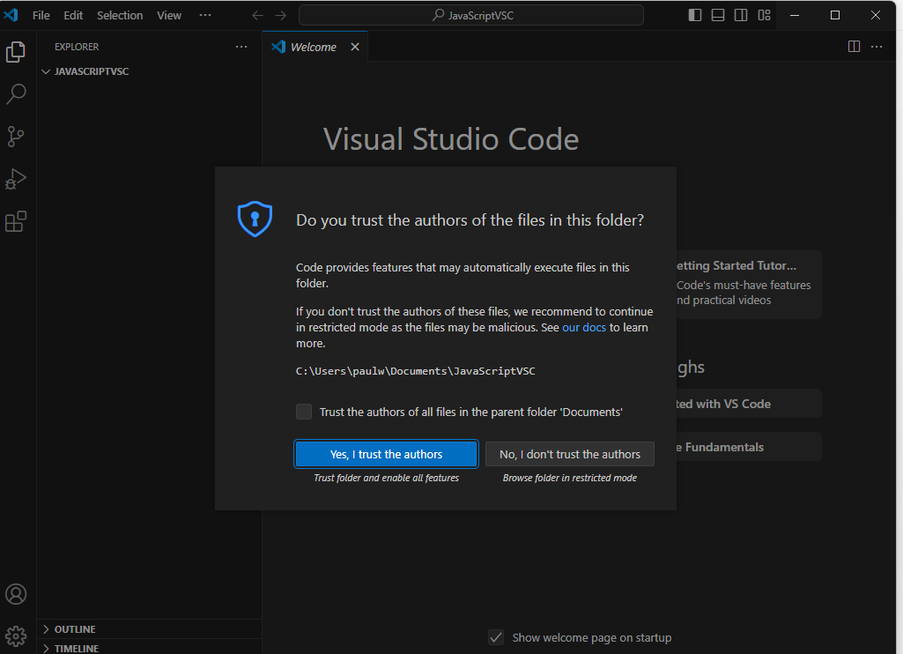
mouse over the javascriptvsc folder in upper left-hand corner and 4 buttons will appear, then click on one that says New File
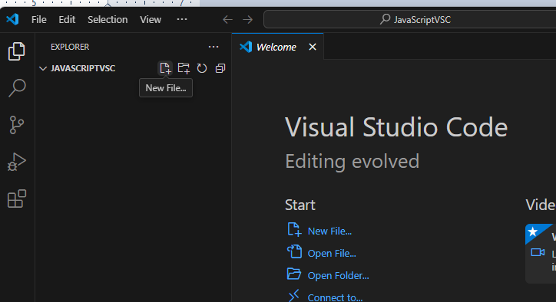
type index.html in box, then click into main box on the right
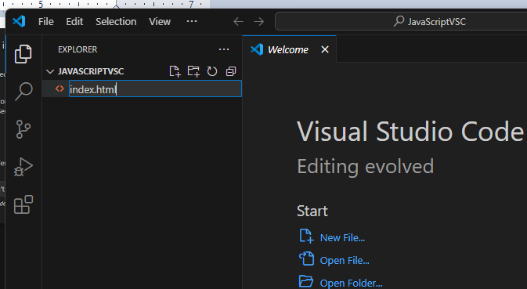
type ! then click tab
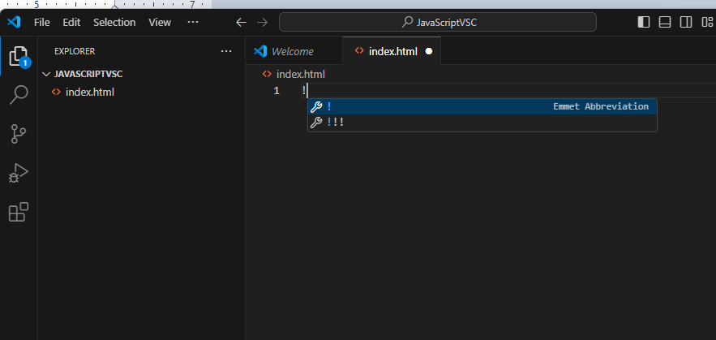
Sample html code will appear, put cursor in middle of <body> tags as shown below
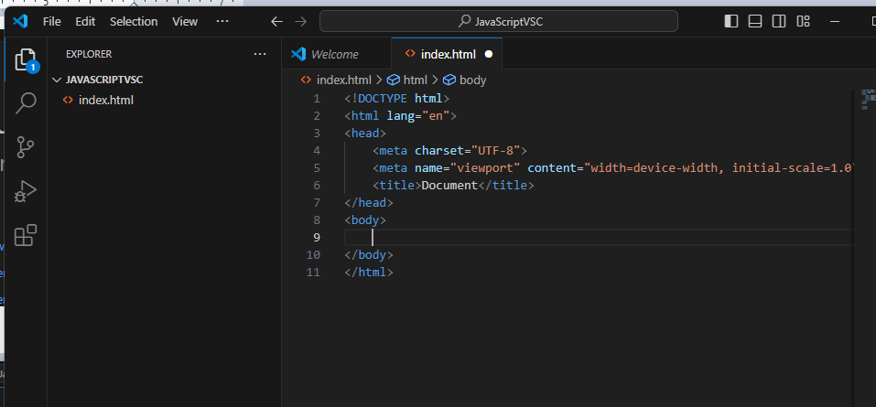
type the following as shown below
<script>
alert("hello");
</script>

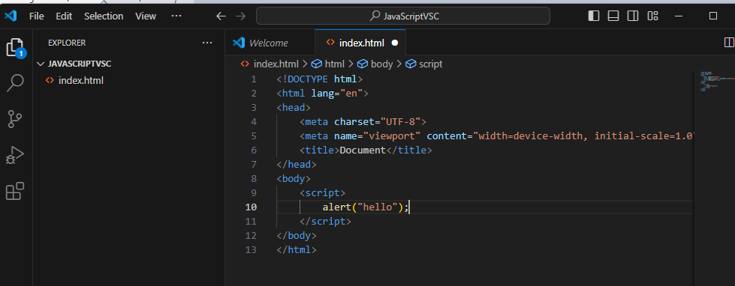
click on the extensions icon on left-hand side
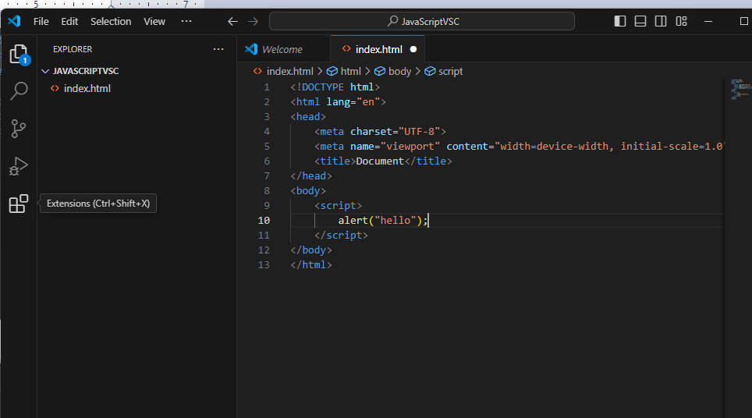
type “Live Server” in search box as shown, and click Install on the first entry
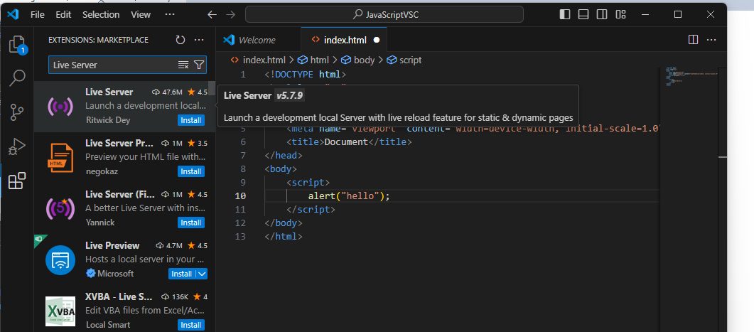
it will install
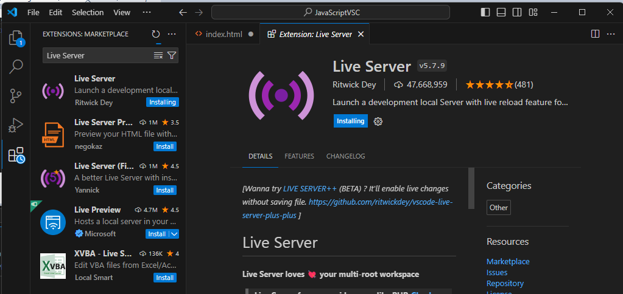
when it is done installing
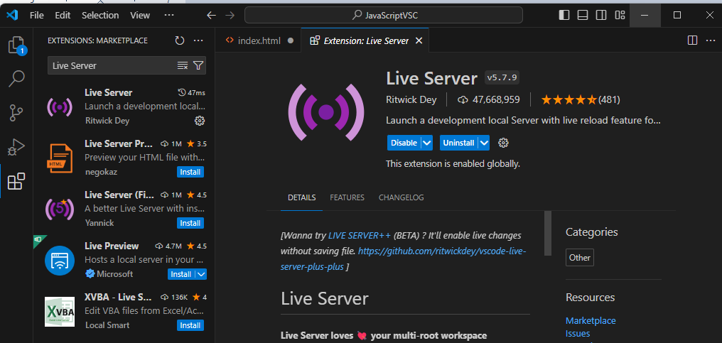
Click on the Explorer icon on left-hand side, to get back to Explorer
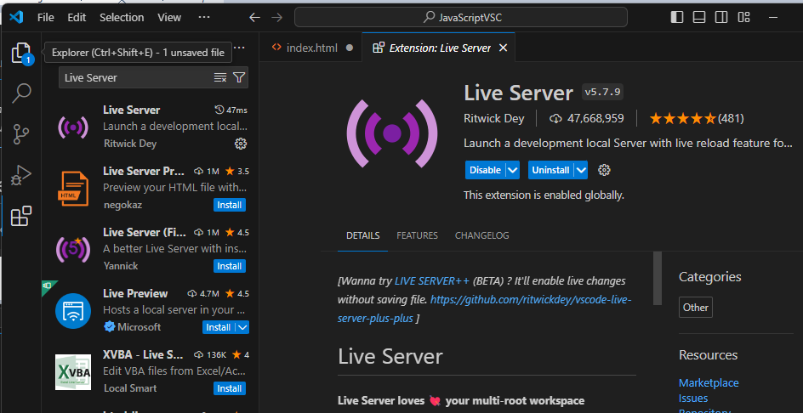
Once you are back into explorer, click on index.html, then right click inside code area and choose Open with Live Server (as shown)
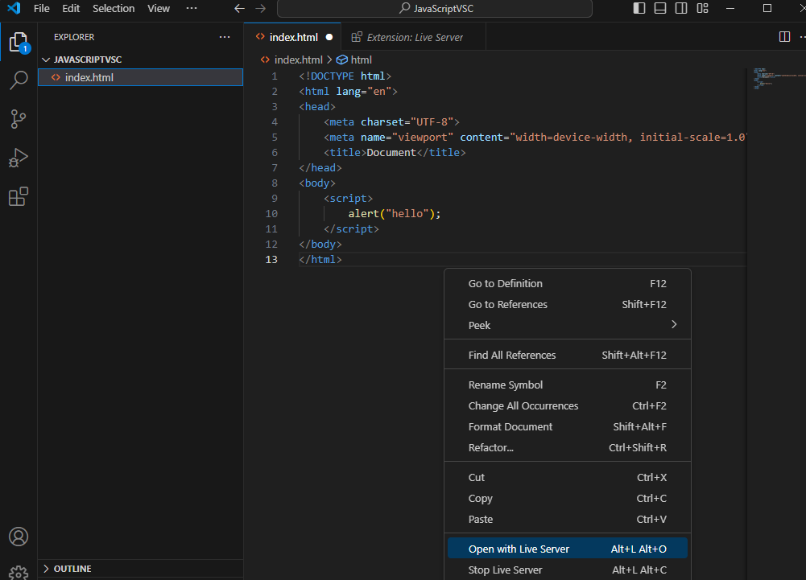
it will pull up the browser with alert box (it may also trigger a firewall warning as shown here)
if you do get the firewall warning, just click on Allow Access
But that is it. You have run your first html file with JavaScript on VCS!
