Python Developers class – Installation guide
Notes: All the software is free, but first you must disable Windows S if you haven’t already

Install VSC (Visual Studio Code)

https://code.visualstudio.com/docs/?dv=win64user
warning: this will automatically download the install file, if it doesn't, click on 'direct download link'

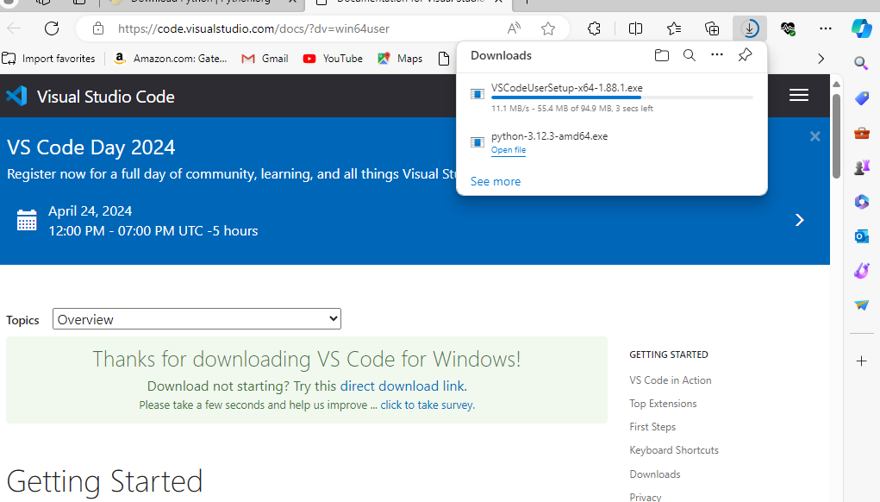

Go to your downloads folder and double click on the file just downloaded

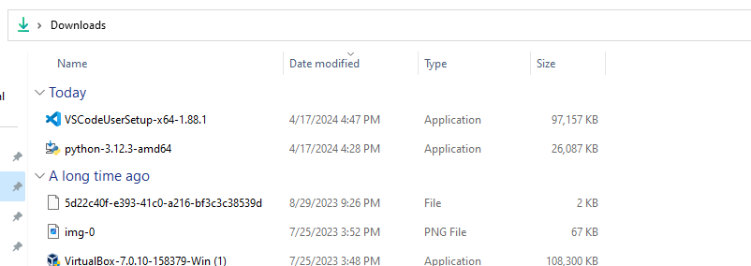

click to Accept then next

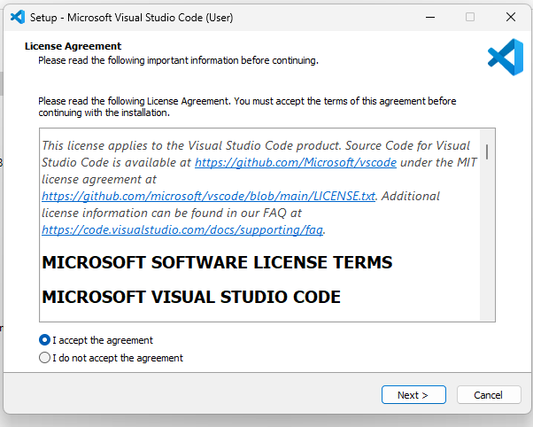

click next

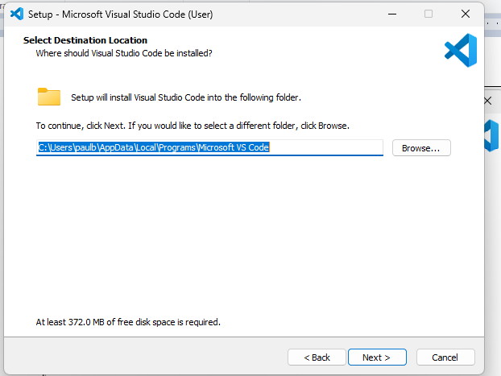

click next

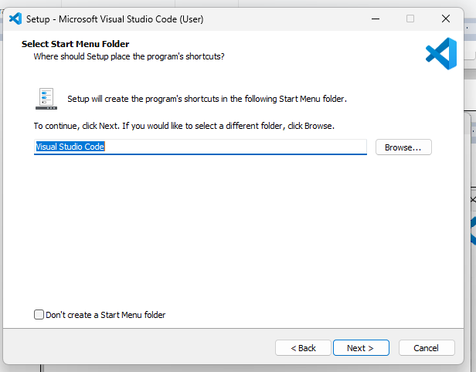

keep the 2 defaults checked, click next again

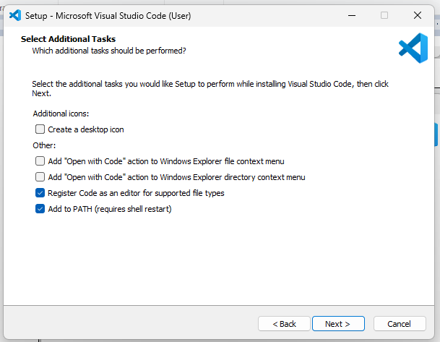
click Install

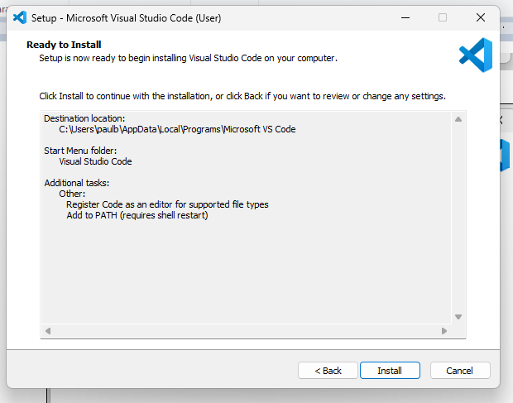

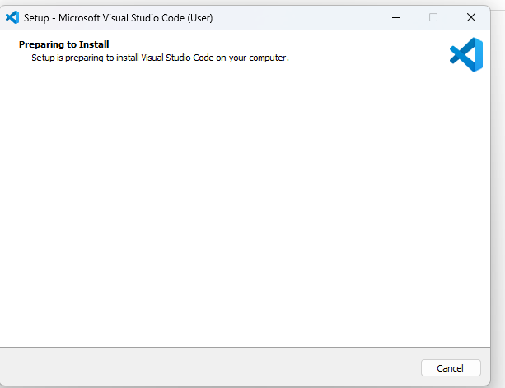

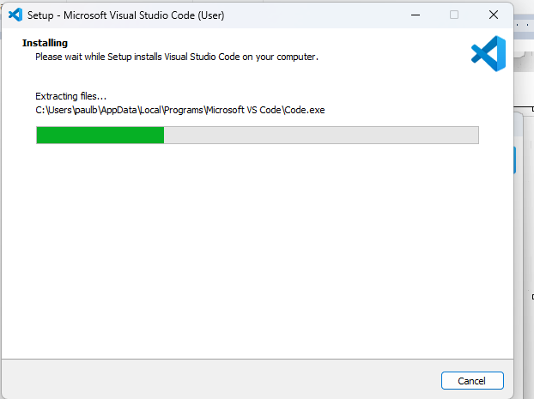

click Finish and launch into VSC
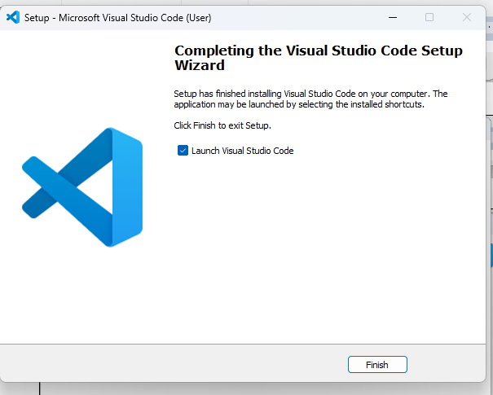

VSC pulls up
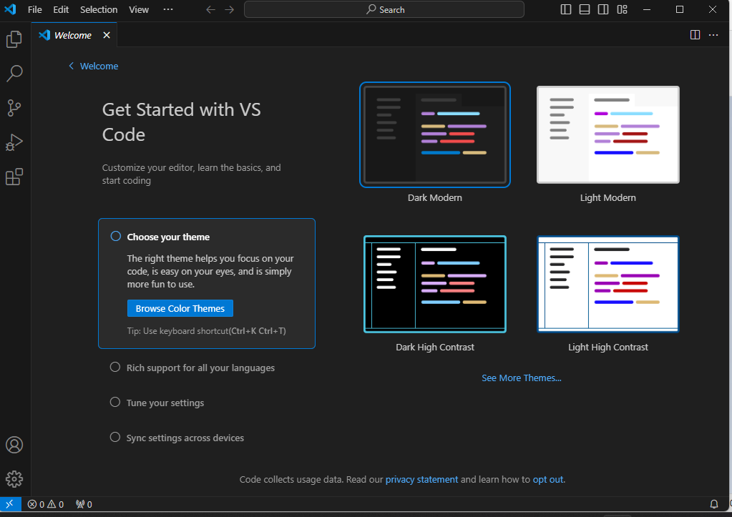

Install Python and Pygame

www.python.org/downloads
click on Download Python...
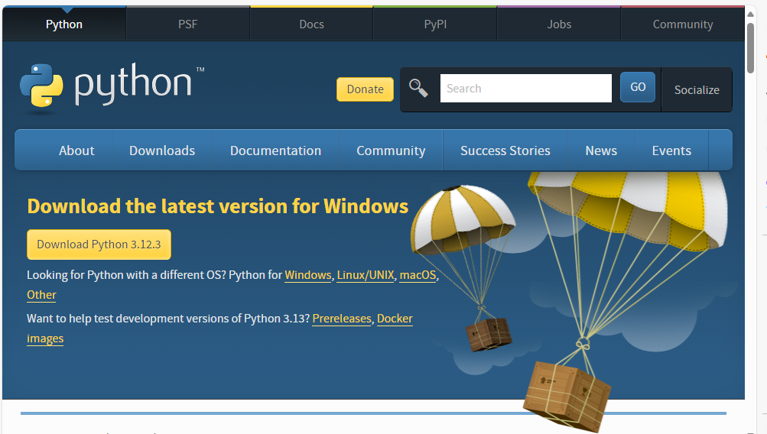

click on Open File in the popup box
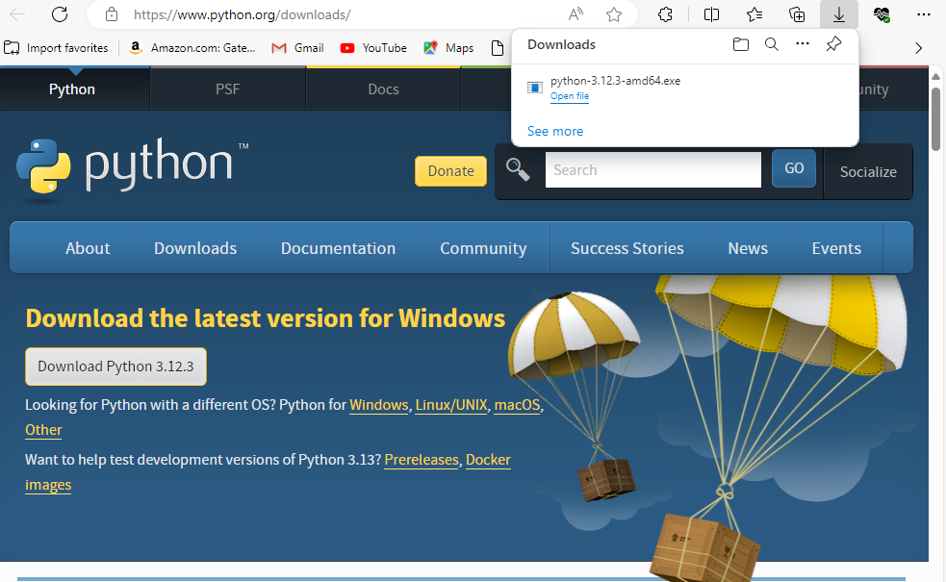
check the 2 checkboxes at bottom, then click on Install Now

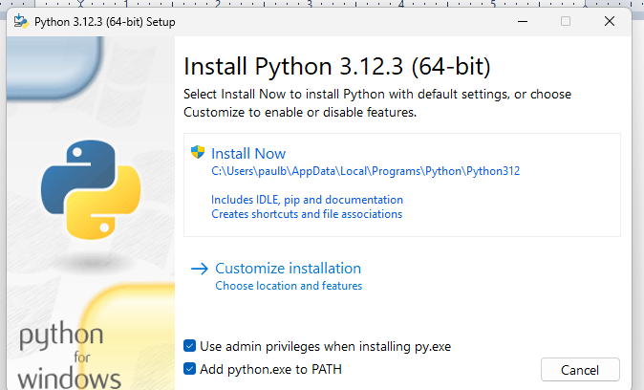

you may get a verify popup from windows, if you do, say yes to it
then you will see

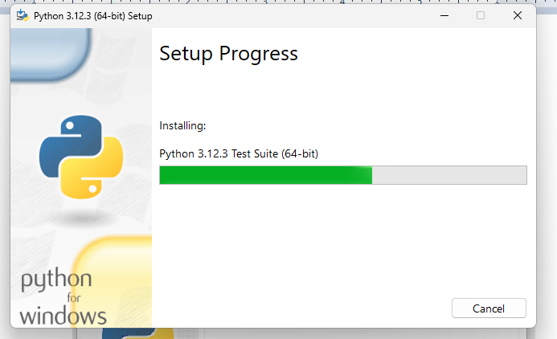
after a few minutes you will see this, please click on Disable path length limit , you may get another verify box, then click X to close box
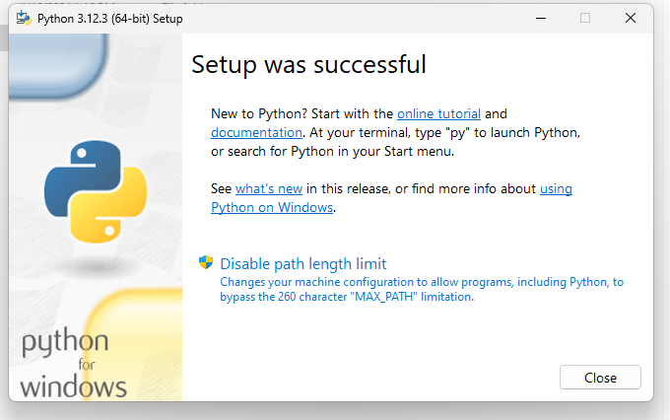
goto command prompt, type the command shown, and you should see the below
pip install pygame
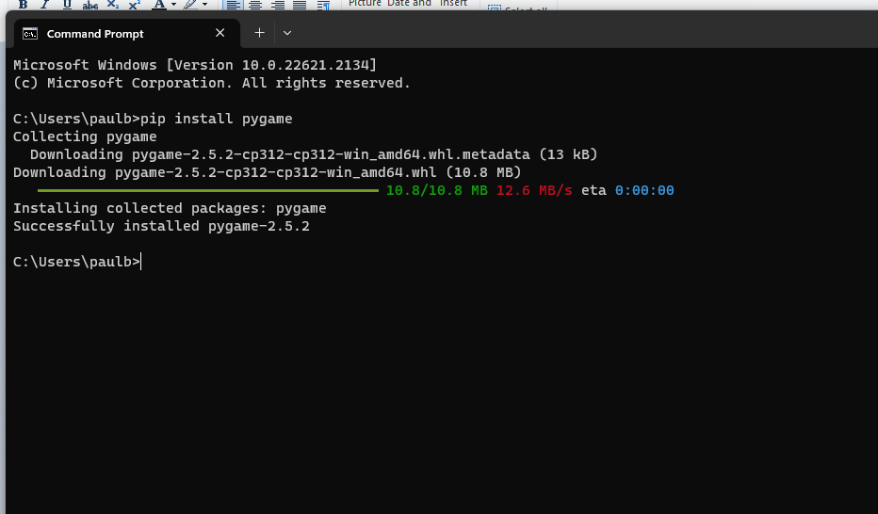

now type the following command and you will see the game pop up as shown
py -m pygame.examples.aliens

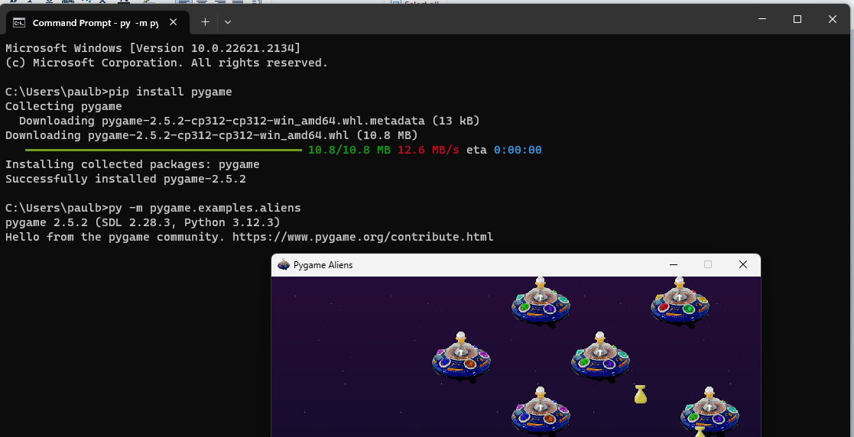

Install Python plugin on VCS then try some Python programming!
First, create the VSCPython folder in your documents folder e.g. C:\Users\paulw\Documents\VSCPython
https://marketplace.visualstudio.com/items?itemName=ms-python.python
click on install button on the page that comes up

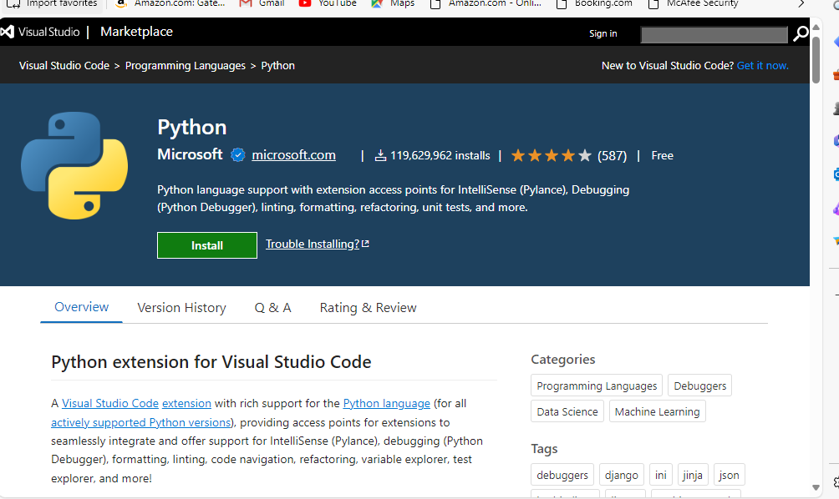

click continue

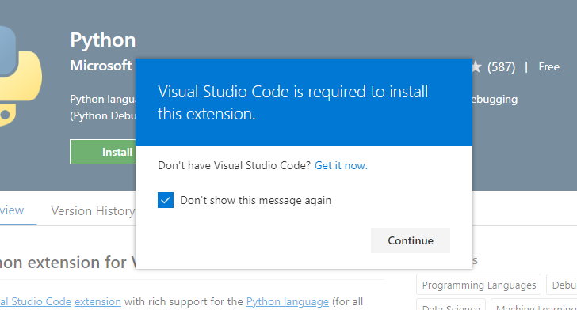

click Open

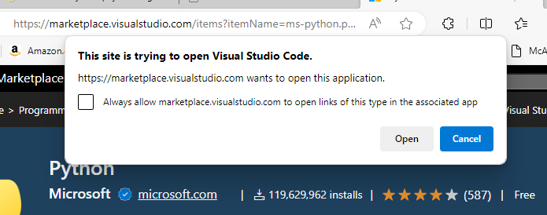

click on install button shown once VSC pops up with this screen

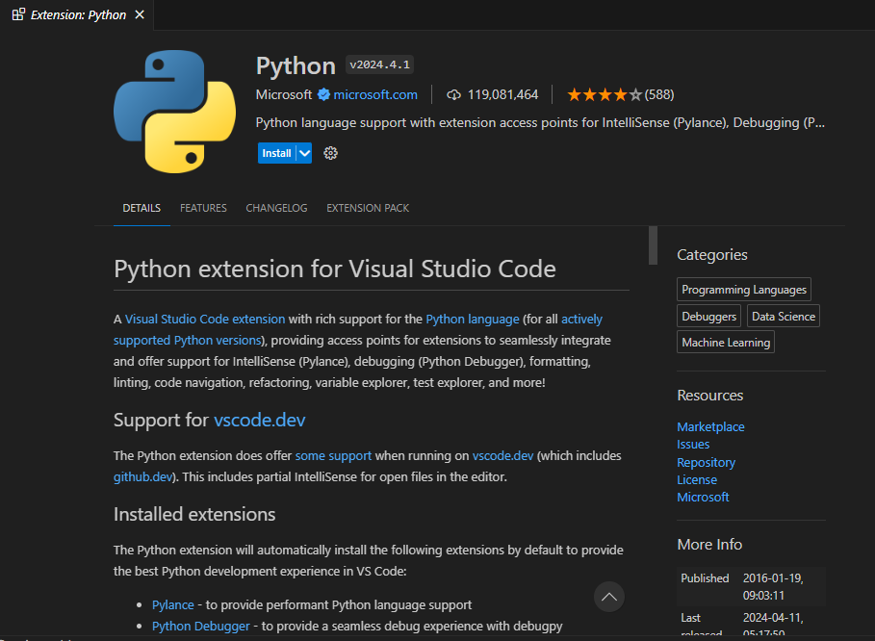
button changes to “Installing”

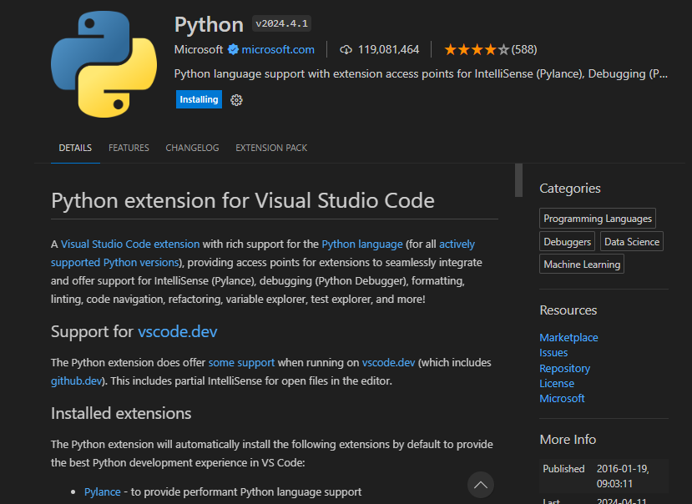
after about 2 minutes (no progress bar), it pops you into welcome screen or another screen if you were already using VSC previously

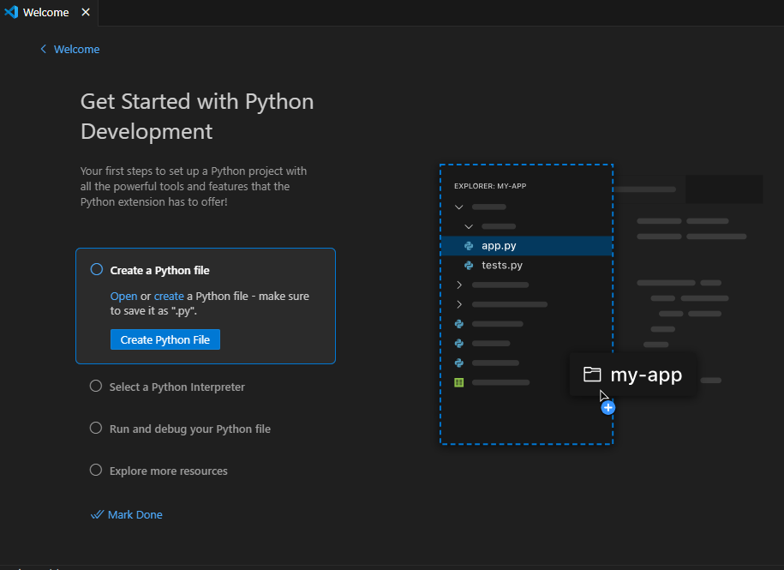
click on Explorer icon on left-hand side

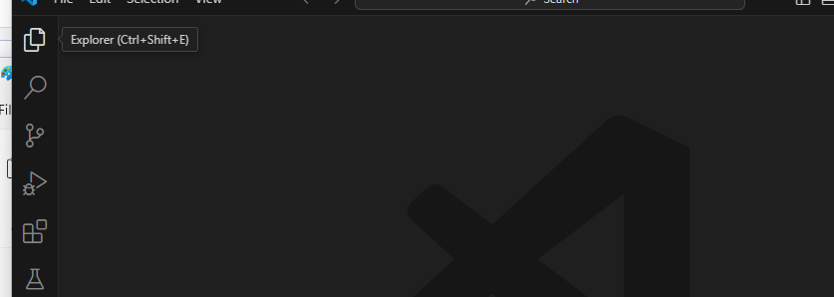
click on Open Folder (if you see that blue button), drill to the VSCPython folder you created earlier and click Select Folder

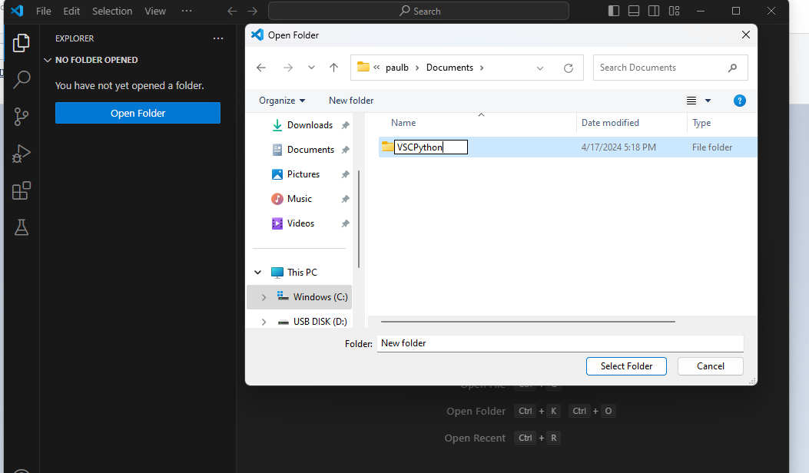

If you don’t see the Open Folder blue button, click on File, then Open Folder, and then drill to your folder like the screenshot above

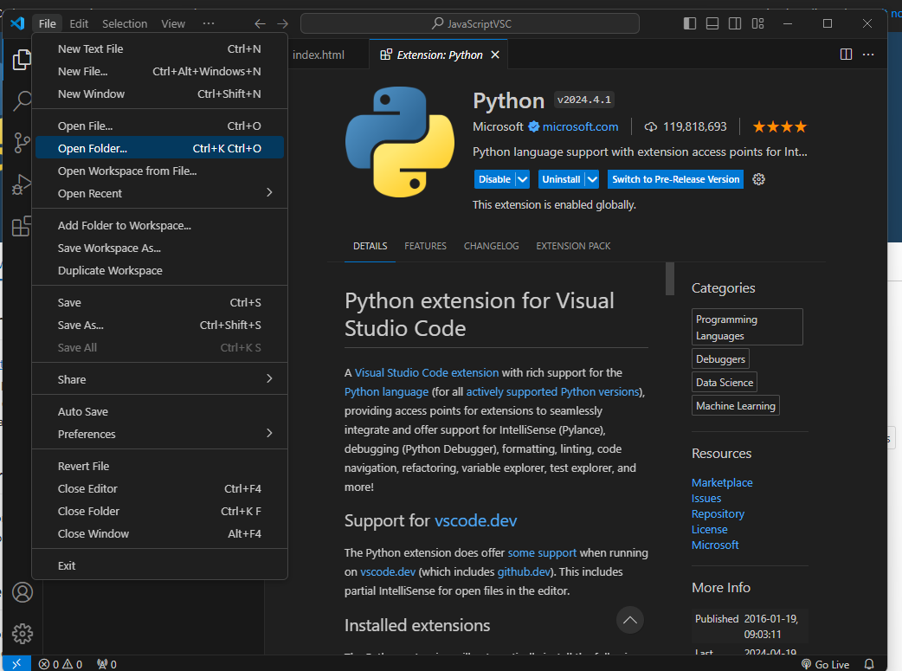
click on “Yes I trust the authors”

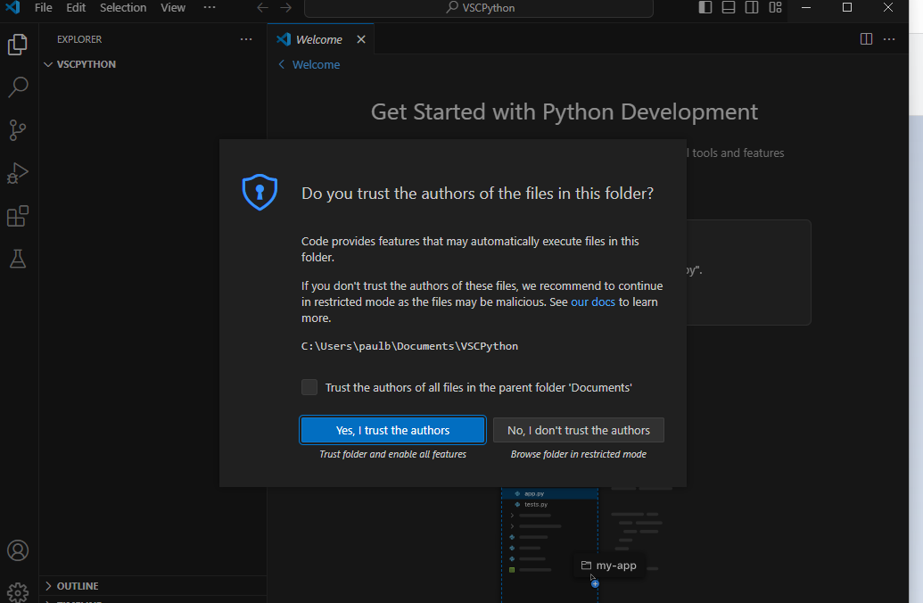
mouse over the folder name in the explorer pane, and click on New File icon

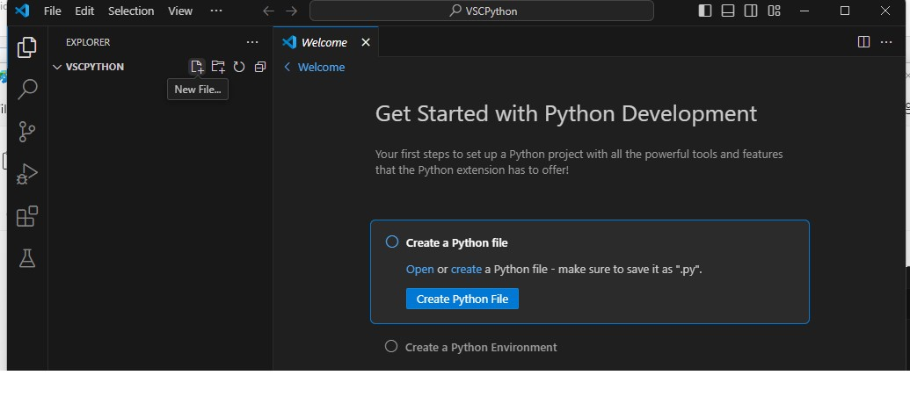

type in filename of hello.py, then click outside of it, start typing code

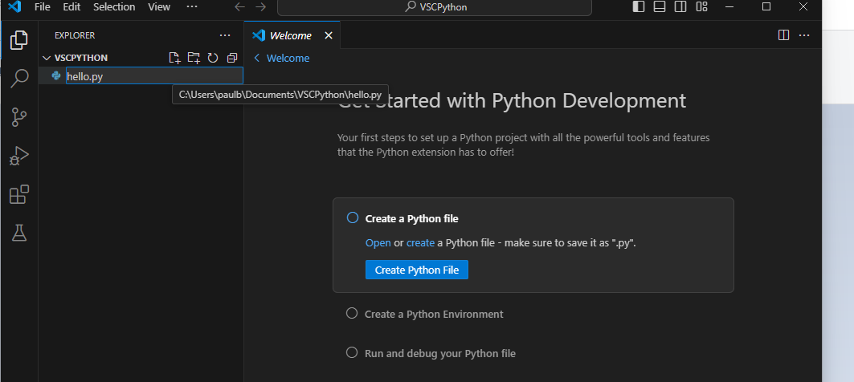

type this code into editor pane on the right-hand side (with no indentation)
import numpy as np
msg = "Roll a dice"
print(msg)
print(np.random.randint(1,9))

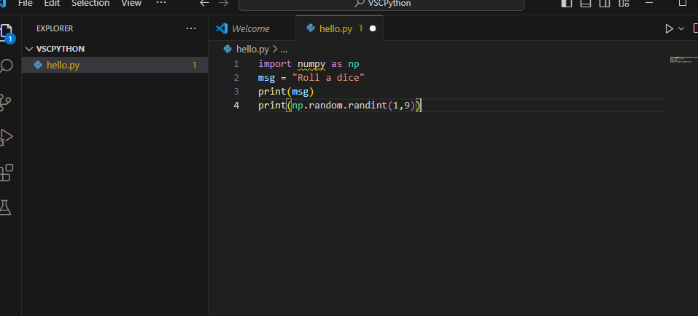
click on play button in upper right-hand corner
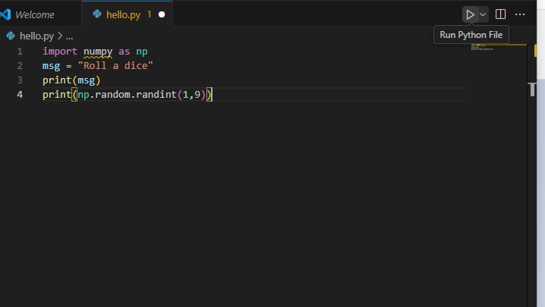
Unfortunately, this doesn’t work because the numpy package doesn't exist. Please see the terminal output at bottom.
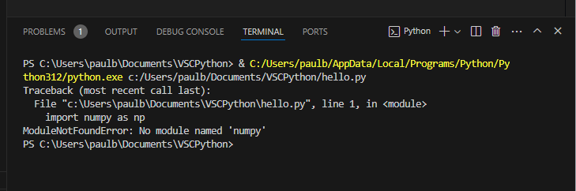
In that same terminal, type this command to install it
py -m pip install numpy
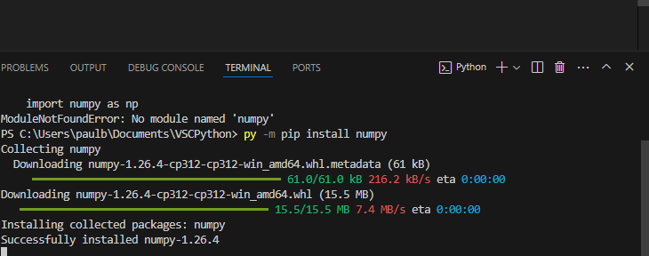
now hit play again and it should work – output will show up in terminal
